Algorithm Theory & Design  
COMP333

# Assignment 1: Part 2 Report

# Bradley Kenny | 45209723 John Kim | 45163782 Mark Smith | 45176655

# Stage 3

## Part 1: computeRatio()

**Brute Force**  
This method started off as a simple division operation of *d1/d2[Fig 1]* but, we found that this was too expensive when we got up to the *computeAllRatio()* method. This was because *d1* would call *routeMinDistance()* every time the ratio must be filled in.



Figure . Rudimentary computeRatio()

**Lookup Table**Realised that operating *routeMinDistance()* for every operation is too expensive and have implemented a lookup table, which functions like if when looking for Chatswood -> Macquarie University, then look up if the combination name *Chatswood-Macquarie University* exists in the table, if not, compute *routeMinDistance()* for all the intermediate stations. That is: *Chatswood-Macquarie University, Chatswood-Macquarie Park, Chatswood-North Ryde*. Then when we look up Chatwood -> Beecroft, it computes *Chatswood-Beecroft, Chatswood-Cheltenham, Chatswood-Epping*, and since we’ve got distance ratio from *Chatswood-Macquarie University*, we stop the computing thereon. This was computed via using a helper method named *mapRatios()*.

## Part 2: computeAllRatio()

**Complete Brute Force**  
A double FOR loop that iterates through all stations in *stationList*, adding other stations to a *HashMap<station i, <station j, computeRatio(I ,j)>>*. However, this resulted in ~35 seconds per test, and looked for any other ways to optimise the method.

**Add(I, j) && Add(j, i)**When adding stations to a new Hashmap, double down on adding stations, that is:  
when we compute HashMap*<station i, <station j, computeRatio(i, j)>>*, operate on its complement station (j), to compute *HashMap<station j, <station i, computeRatio(I, j)>>*. This has reduced the resulting time to ~15 seconds per test.

**Lookup Table Integration**This lookup table method was using a dynamic programming approach where the code recognises that there are identical sub problems found within. Such as *Chatswood -> Beecroft* and *Chatswood -> Macquarie University* will shave a subproblem that is *Chatswood -> Macquarie University[Fig 2]*. Using the newly altered *computeRatio()*, resulting time was reduced down to ~4 seconds per test.

Overlapping problem

|  |  |  |  |  |  |  |
| --- | --- | --- | --- | --- | --- | --- |
| Chatswood | North Ryde | Mq Park | Mq Uni | Epping | Cheltenham | Beecroft |

Figure 2. Identical subproblem in computeAllRatio()

**Floyd Warshall**Upon being stuck at ~4 seconds for the best result, we’ve tried to Google for some hints that may lead to the solution. Results from Google suggested looking into “Floyd-Warshall”, “Bellman-Ford”, “Johnson’s” algorithms, and after inspecting their intended use, we’ve decided that Floyd-Warshall was the one we should be attempting to integrate.

Using GeeksForGeek’s algorithm template for Floyd-Marshall[1], we were able to produce a rudimentary solution[Fig 3]. It operates on the same basis of implementing O(n^2) for populating a HashMap with *Integer.MAX_VALUE*, much like *routeMinDist()* from Stage 1, and once the double FOR loop, replace the corresponding distance values with the correct ones. Using Floyd-Marshall, map out the *Stations* and *computeRatio()*. This resulted in ~2.3 seconds per test.

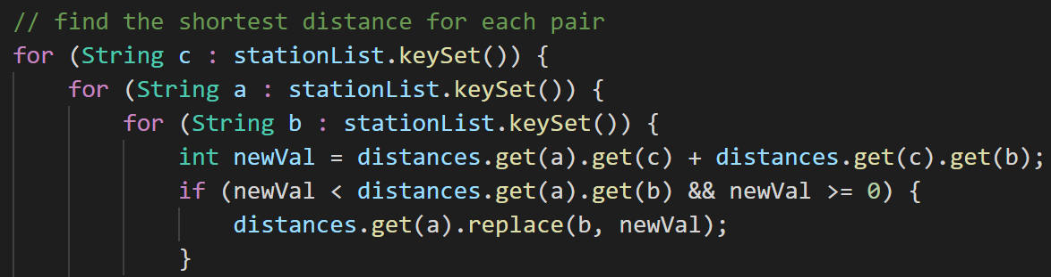

Figure 3. Simple Floyd-Marshall

**Final Solution**A minor fix from the prev stage has reduced from ~2.3 seconds to sub 1 second. Instead of calculating *computeRatio()* at every loop, only calculate on each final distance[Fig 4].

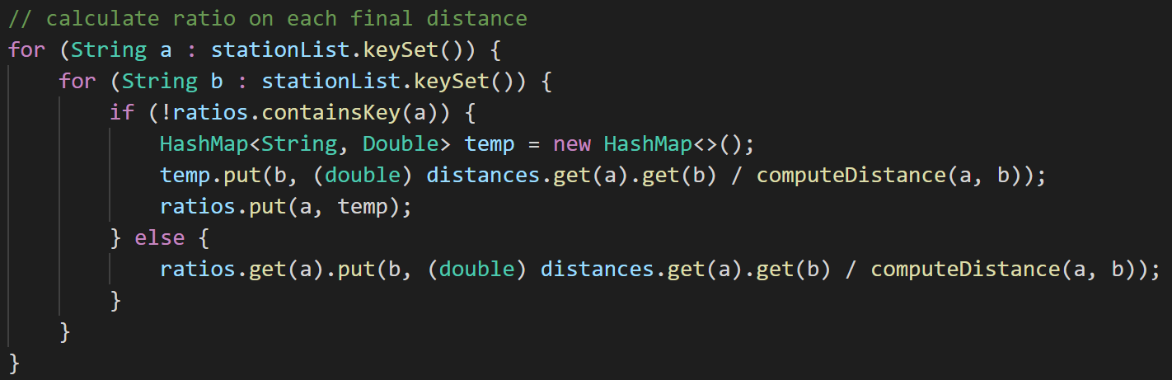

Figure 4. Final computeRatio() solution

# Stage 4

## routeMinStopWithRoutes()

We’ve started this stage off *routeMinStop()* from Stage 1, which was based off GeeksForGeek’s BFS template algorithm[2]. Our line of thinking was that create a new data structure that takes in information from *lines_data.csv* and integrate the new line code, line name and station number in the corresponding station line. A *TreeMap<String, HashMap<Integer, String>>*[Fig 5] that corresponds to <train line code, <station number, station name>>.

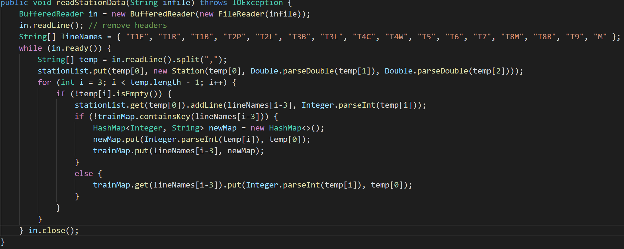

Figure . Data structure for lines_data.csv

Replacing *adjacentStations* from Stage1 with stations found in the station code lines. Simply put, get the *origin* Station and add to a *PriorityQueue*, and using *pq.poll()* and trawl through the list of train lines and if found, add adjacent stations to pq[Fig 6]. For example, If Chatswood = Origin, find all the station lines (T1E, T1R, T1B, T9 & M) and add adjacent stations to the pq, that is: Roseville, Artarmon, and North Ryde. Then using *pq.poll()* BFS through all the stations until the line reaches destination.

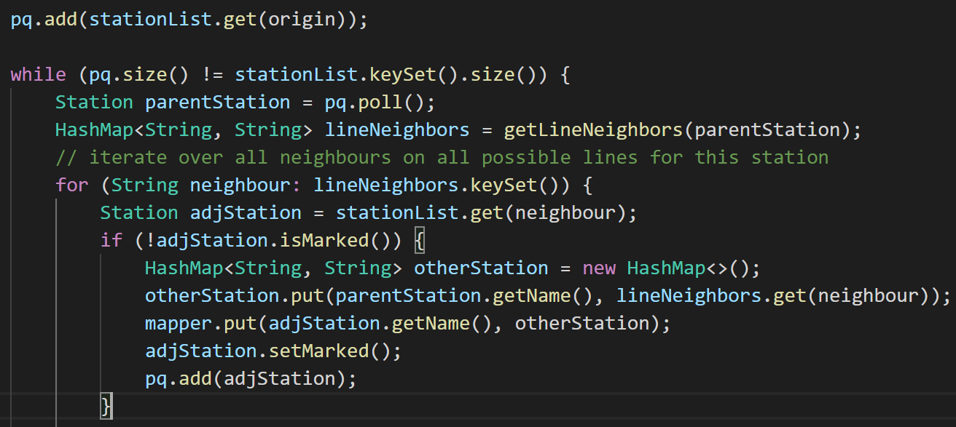

Figure . Implementation of GFG’s BFS

A helper method[Fig 7] that determines which are the neighbouring stations from each train line list. While iterating through all the possible stations, we need to keep track of which way it’s going towards, and this can be judged using station number, which this method tries to achieve. It written to be used for creating an output for A -> Z or Z -> A; Hornsby towards Gordon or Gordon towards Hornsby.

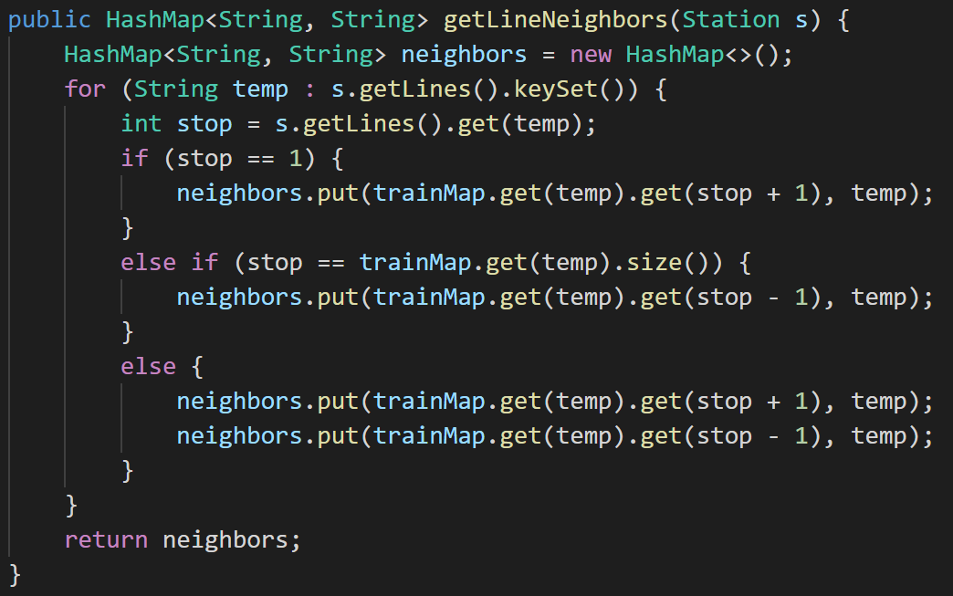

Figure . Neighbouring stations and direction determiner

Once the function reaches the destination, then it builds an ArrayList in reverse from Destination to Origin. One of the more difficult part of producing the output is the custom writing that signifies when trainline has been changed, for example, Beecroft -> Chatswood: T9 to Epping, from Epping, change to Metro to Chatswood. This method[Fig 8] looks at the station’s previous line, if the number successfully increases/decreases by 1, then they’re still on the same train line. Otherwise, it has changed train line and update the station number.

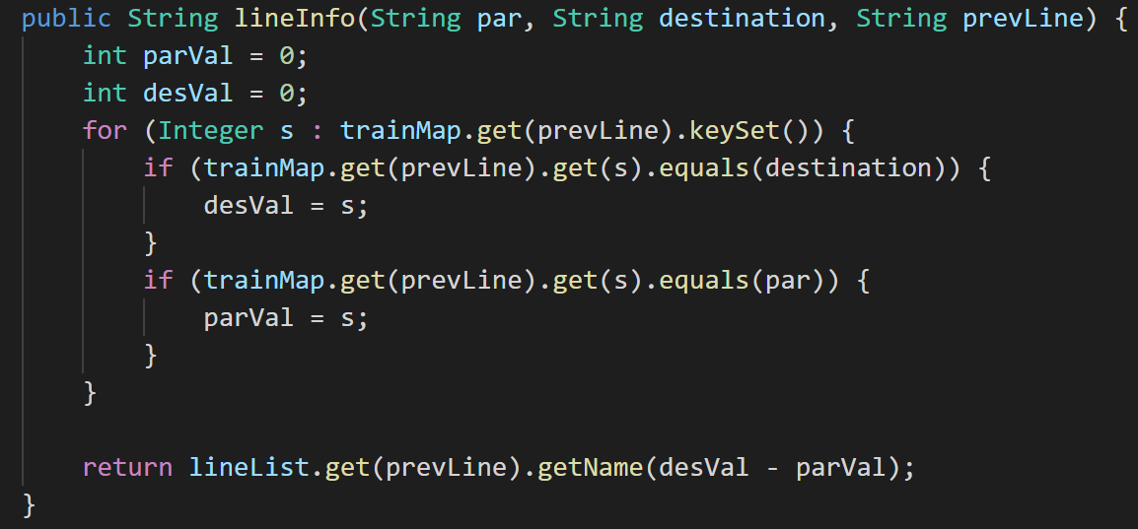

Figure . Get trainline name associated to the stop

**Successful Tests**

Having written tests[Fig 10] of our own, we were able to produce some successful results[Fig 9].

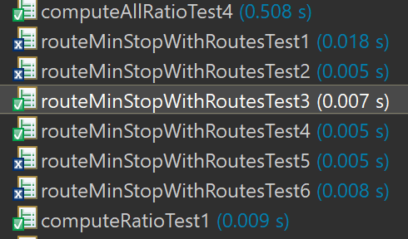

Figure . Successful tests results

**Test 3 Output**: [T9 towards Hornsby from Gordon, Epping, Eastwood, Denistone, West Ryde, Meadowbank, Rhodes, Concord West, North Strathfield, Strathfield]

**Test 3 Actual**: arrays first differed at element [0]; expected:<T9 towards [Gordon from Hornsby]> but was:<T9 towards [Hornsby from Gordon]>

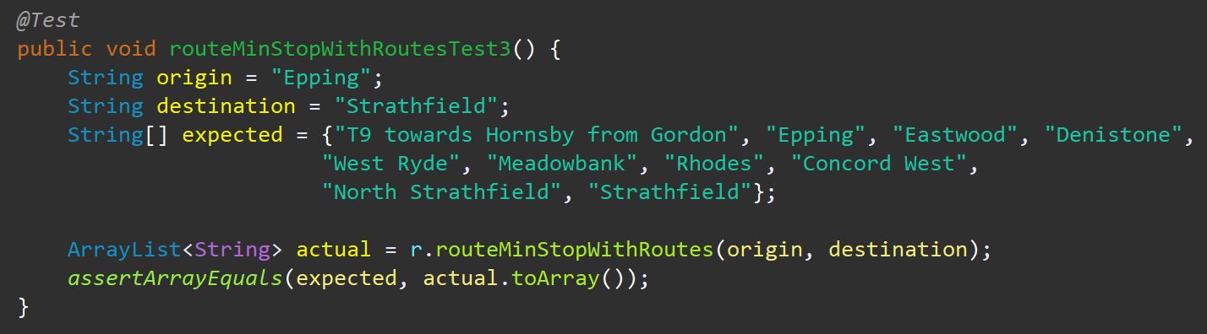

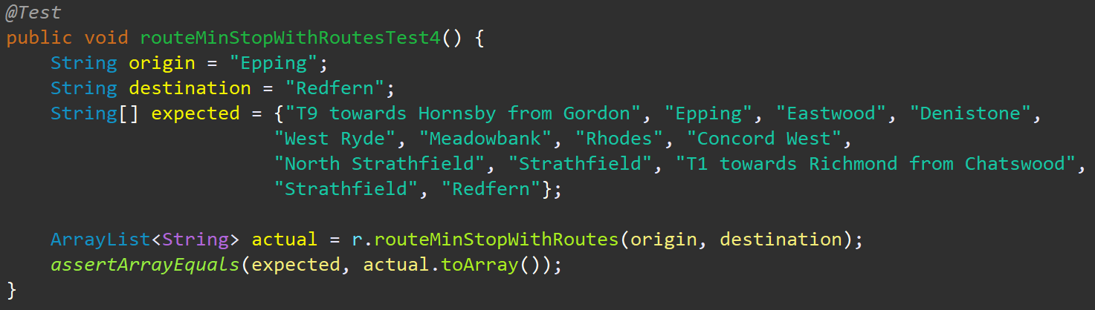

Figure . 2 of 6 tests created to check for its success

**Correctly Identifying “Express” Lines**

**Test 5**[Fig 11] **Output:** [T9 towards Hornsby from Gordon, Hornsby, Normanhurst, Thornleigh, Pennant Hills, Beecroft, Cheltenham, Epping, Eastwood, Denistone, West Ryde, Meadowbank, Rhodes, Concord West, North Strathfield, Strathfield, Burwood, T2 towards Leppington from Museum, Burwood, Ashfield]

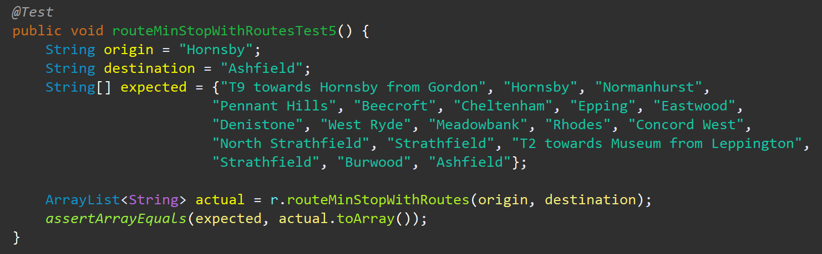

Figure 11. Test 5 which tests express line T2L

This test correctly identifies the differences between the train line T2[Fig 12] which by default traverses Strathfield -> Burwood -> Croydon -> Ashfield. However, taking T2L will skip Croydon and make an express trip from Burwood, straight to Ashfield.

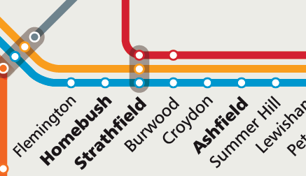

Figure 12. T2 train line

This test is significant as it successfully differentiates itself from routeMinStop() from Stage 1 and also successfully BFS through different train line codes (T2P vs T2L).

**Unsuccessful Tests**

As it can be seen below, our code incorrectly identifies which direction the train is moving towards. We believe that this is due to creating a path ArrayList backwards (destination to origin) and it is adversely affecting it’s navigation. However, if we were to smooth out this operation, we would have been able to successfully produce correct output.

**Test 1 Output:** [T9 towards Hornsby from Gordon, Beecroft, Cheltenham, Epping, Metro towards Epping from Chatswood, Epping, Macquarie University, Macquarie Park, North Ryde, Chatswood]

**Test 1 Actual:** arrays first differed at element [0]; expected:<T9 towards [Gordon from Hornsby]> but was:<T9 towards [Hornsby from Gordon]>

**Test 6 Output:** [T8 towards Macarthur from Town Hall, Macarthur, Campbelltown, Leumeah, Minto, Ingleburn, Macquarie Fields, Glenfield, T5 towards Leppington from Schofields, Glenfield, Casula, Liverpool]

**Test 6 Actual:** arrays first differed at element [0]; expected:<T8 towards [Town Hall from Macarthur]> but was:<T8 towards [Macarthur from Town Hall]>

1. <https://www.geeksforgeeks.org/floyd-warshall-algorithm-dp-16/>
2. <https://www.geeksforgeeks.org/breadth-first-search-or-bfs-for-a-graph/>